Adverse Drug Reaction Reporting
From version 7.1 mSupply mobile includes the ability to report on Adverse Drug Reactions It is able to be used with AEFI (Adverse Events From Immunisation) reporting.

Set up

Entering an adverse reaction report
To report, a patient must be entered. If you are at the facility where the drug was administered, the patient should already be in the system.
If the patient isn't in the list:
- Tap the Lookup Patient button to query the central server to retrieve their name.
- If you still can't find them (which should be rare), then you can tap New Patient to enter their details.
Once the patient is found, tap the plus icon in the ADR column to add an adverse event report for that patient.
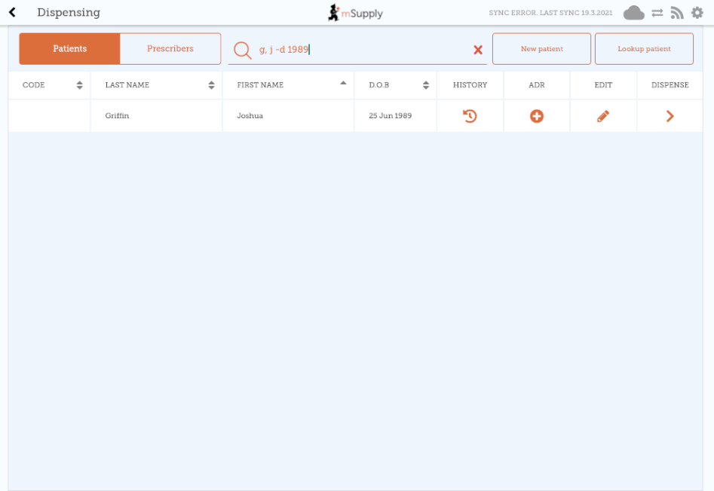
What is shown on the form is configurable on the server. If more than 1 adverse reaction form has been defined, you will be shown a list of forms, and you need to choose the appropriate one before proceeding.

